QuArk Map Editor for Mahatta Tutorial

Installing and Configuring QuArk

The Mahatta engine

First off, make sure the Mahatta game engine runs in your machine. Assuming you already have Mahatta installed, simply run Mahatta.exe. If the game runs fine, then you are good to go.

Necessary installation files

These are the needed files for installation:

QuArk – This is the map editor. You can download this at the following link:

http://dynamic.gamespy.com/~quark/

Q3MAP2 – compiles the map made by Quark into a BSP file format that Mahatta game engine uses. Download the latest version at:

http://shaderlab.com/q3map2/

Latest version is in the folder with the highest number e.g. (08-Jul-2004):

http://shaderlab.com/q3map2/2.5/

Installation

QuArk – Depending on the version of QuArk, either run the setup executable and follow the steps or extract the file with WinZip (or other) to a folder, e.g.: C:\QuArk\.

Q3MAP2 – Extract the archive file to any folder, e.g.: C:\Q3MAP2 or C:\QuArk\Q3MAP2 (for less confusion).

QuArk Configuration

First off, you will need to copy necessary files to QuArk in order to make maps for Mahatta.

Extract the contents of MahattaQuarkFiles.zip to <QuArk folder>\addons\ (Make sure to preserve folder path and overwrite all files).

Run QuArk

On the top right of the window is the item: Games, click on it and click on Mahatta (If you do not see this item, then you did not extract MahattaQuarkFiles.zip correctly).

Click on Games again and this time, click on Configuration… The following screen should show:

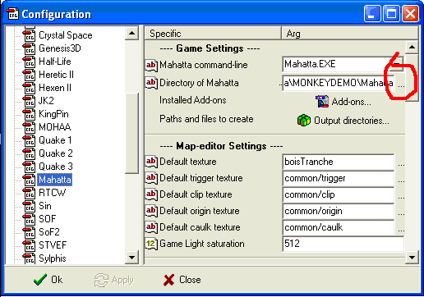

Under Game Settings, click on ‘…’ to the far right of Directory of Mahatta, find the path to where Mahatta.EXE resides and click OK.
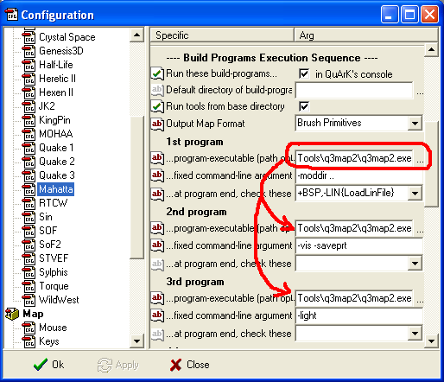

Under Build Programs Execution Sequence, click on ‘…’ to the far right of the program-executable of 1st program, find the path to where the q3map2.EXE resides (where you extracted Q3MAP2, e.g. C:\q3map2) and click Open.

Copy the path to both 2nd and 3rd program executable path.

You are all set, now click on the OK button to save and exit the configuration.

